Artificial Intelligence Lab# 2

1. Define the following terms:

* **Regular Graph**

A regular graph is a graph where each vertex has the same number of neighbors; i.e. every vertex has the same degree or valency.

* **Null Graph**

A null graph is a graph which has no vertices, i.e. it is a graph of order zero.

* **Trivial Graph**

A graph having only one vertex in it is called a trivial graph. It is the smallest possible graph.

* **Simple Graph**

A graph having no self-loops and no parallel edges in it is called as a simple graph.

* **Connected Graph**

A graph in which we can visit from any one vertex to any other vertex is called as a connected graph.

* **Disconnected Graph**

A graph in which there does not exist any path between at least one pair of vertices is called as a disconnected graph.

* **Complete Graph**

A graph in which exactly one edge is present between every pair of vertices is called as complete graph.

* **Cyclic Graph**

A simple graph of ‘n’ vertices (n >= 3) and n edges forming a cycle of length ‘n’ with all its edges is called as cycle graph.

* **Degree of Vertex**

The degree of vertex of a graph is the number of edges incident to the vertex.

* **Loop**

A loop is an edge that connects a vertex to itself.

* **Parallel Edges**

Parallel edges are two or more edges that are incident to the same two vertices.

1. Consider the following graph:

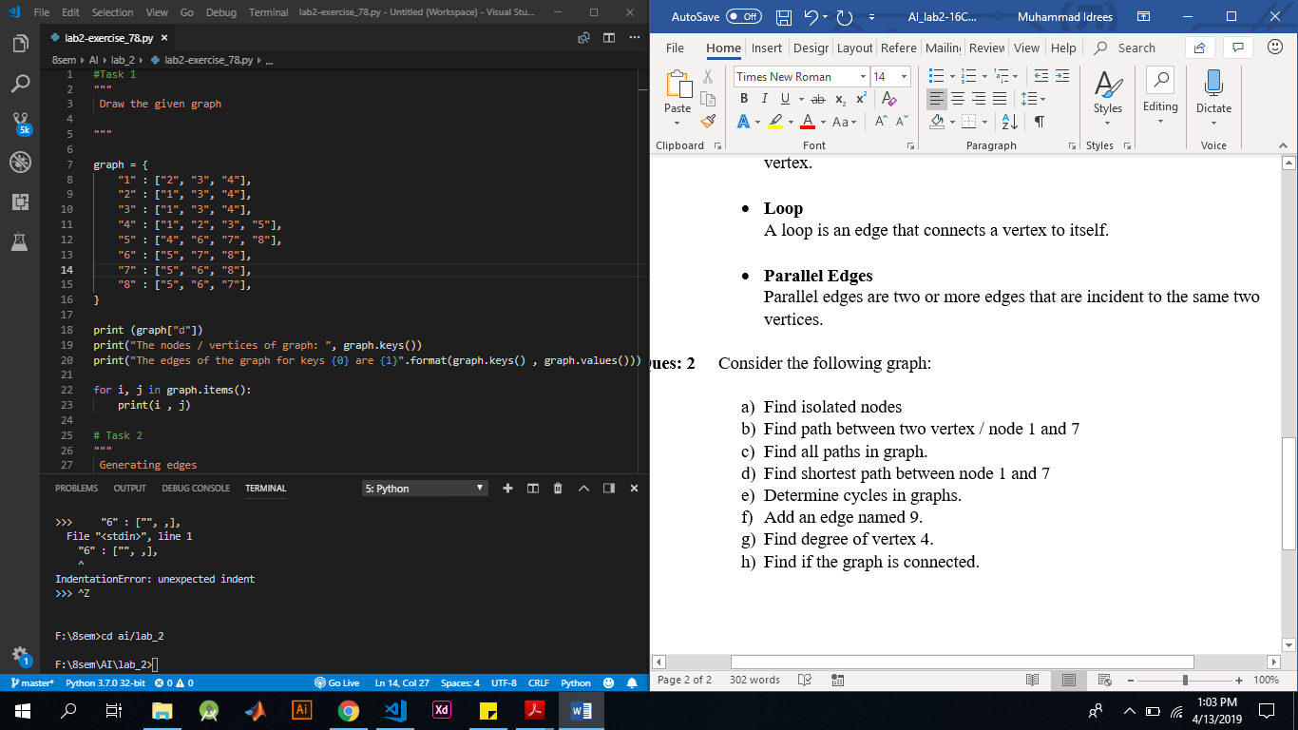

1. Find isolated nodes

Code:

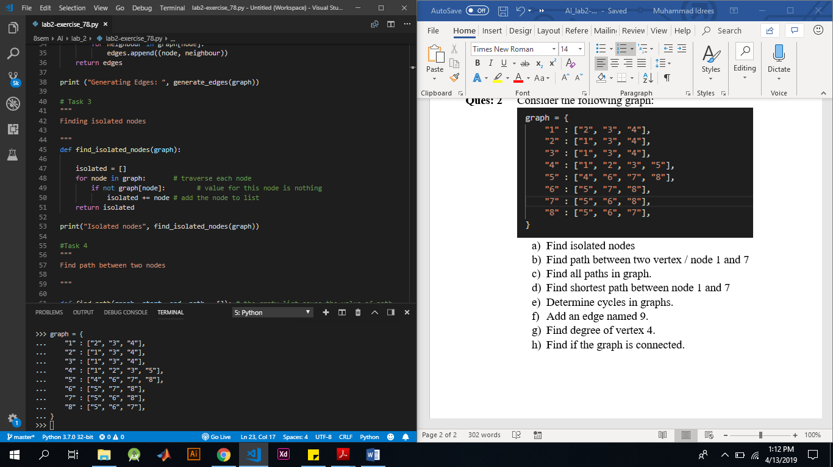

Answer:

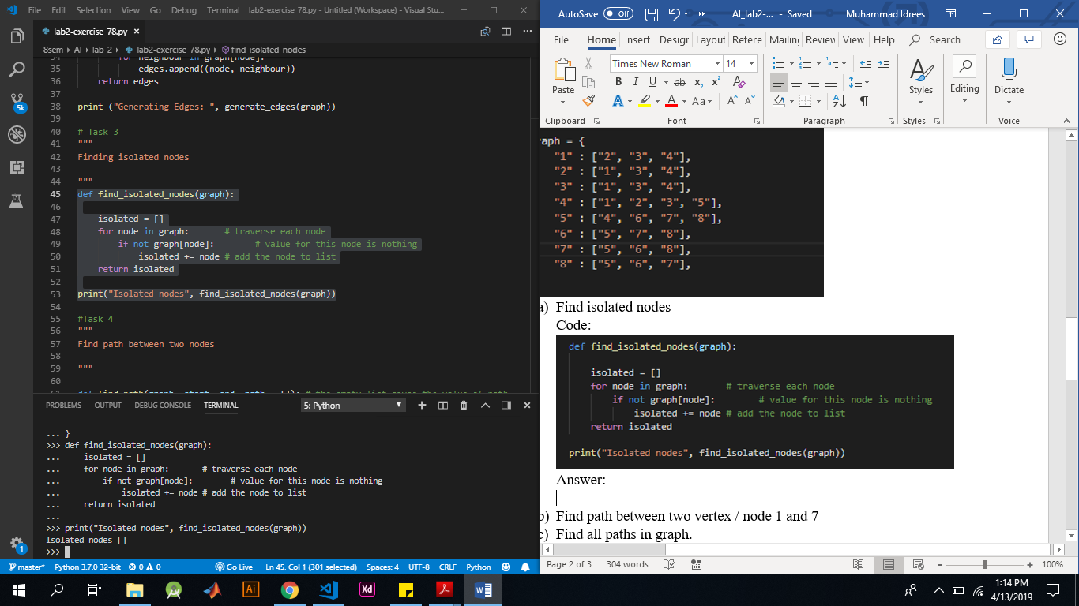

1. Find path between two vertex / node 1 and 7

Code:

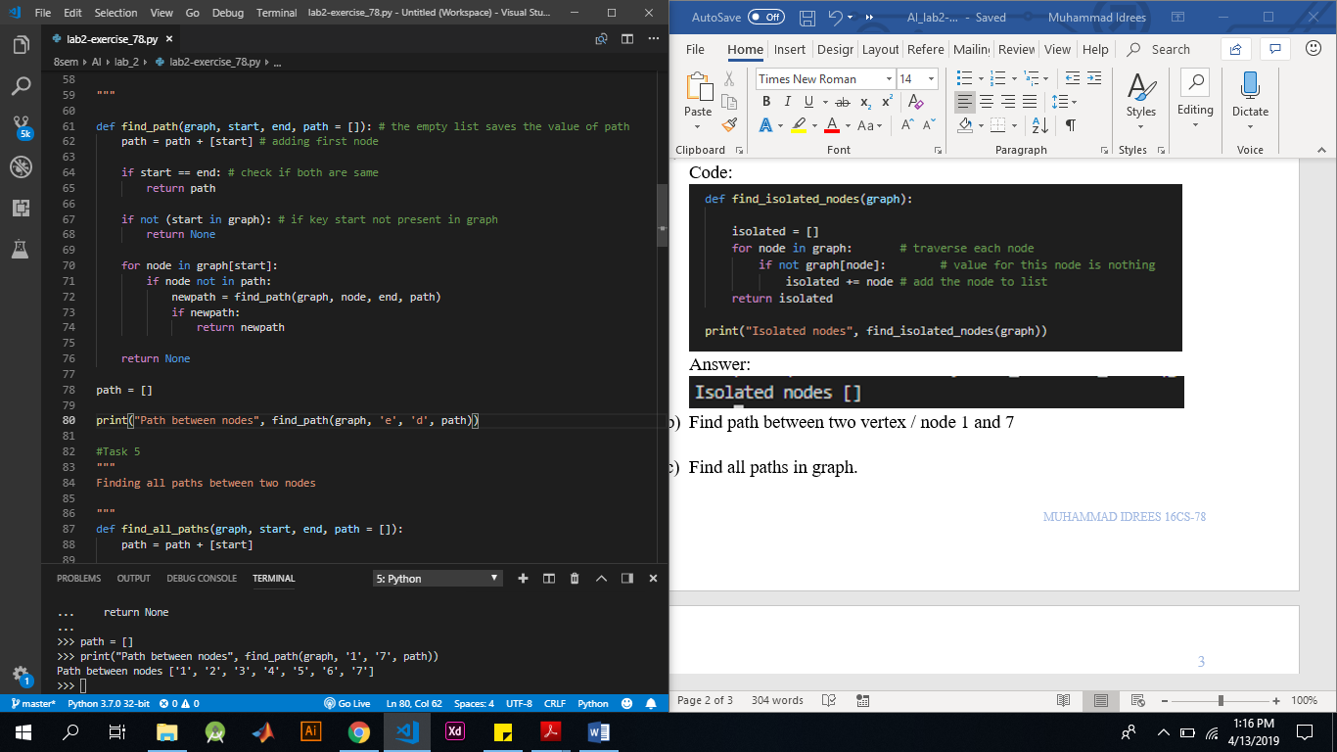

Answer:



1. Find all paths in graph.

Code:

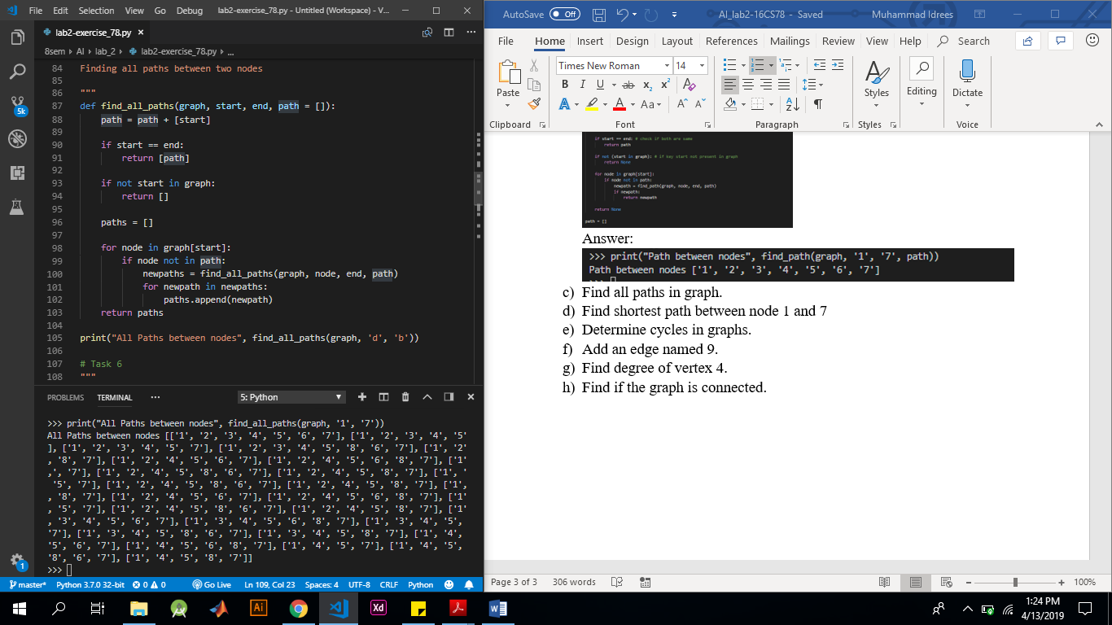

Answer:



1. Find shortest path between node 1 and 7

Code:

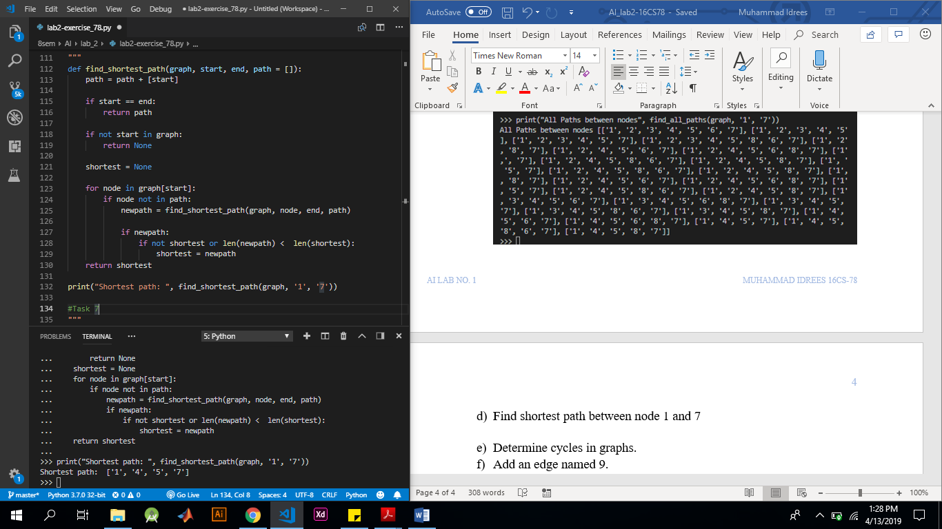

Answer:



1. Determine cycles in graphs.

Code:

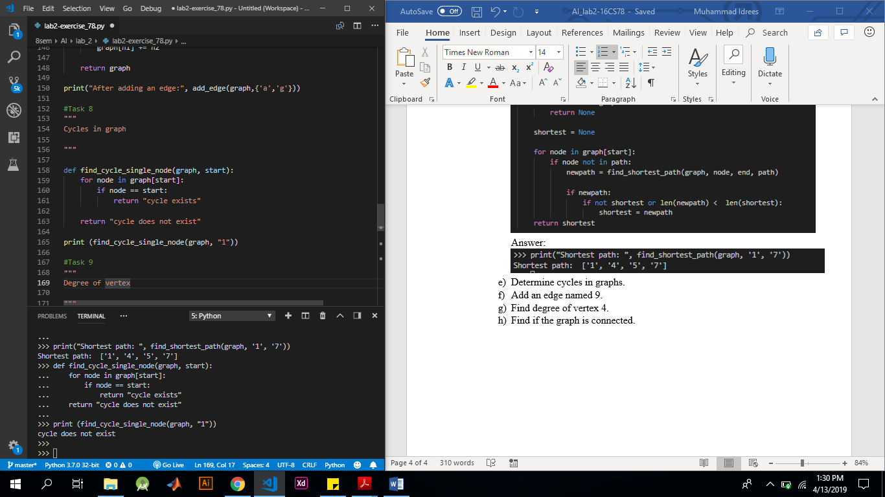

Answer:



1. Add an edge named 9.

Code:

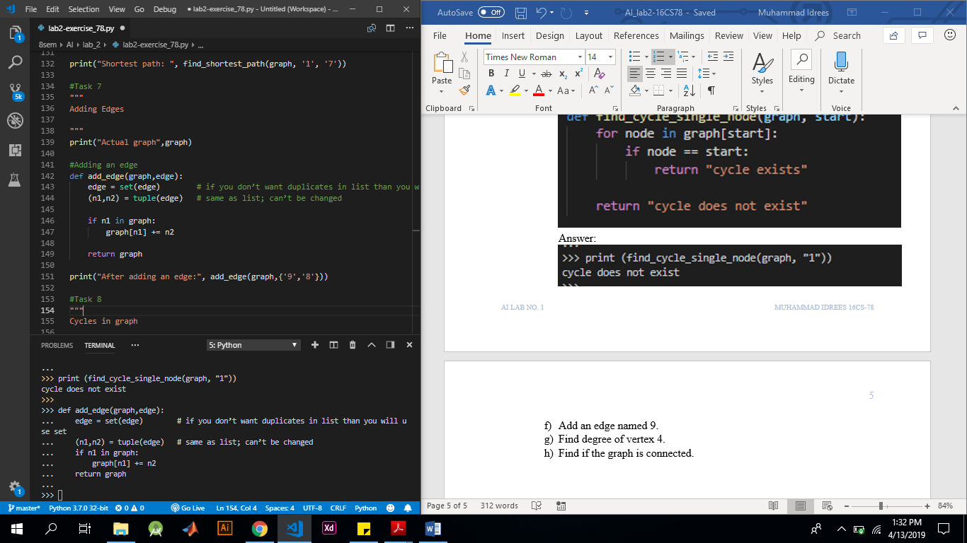

Answer:

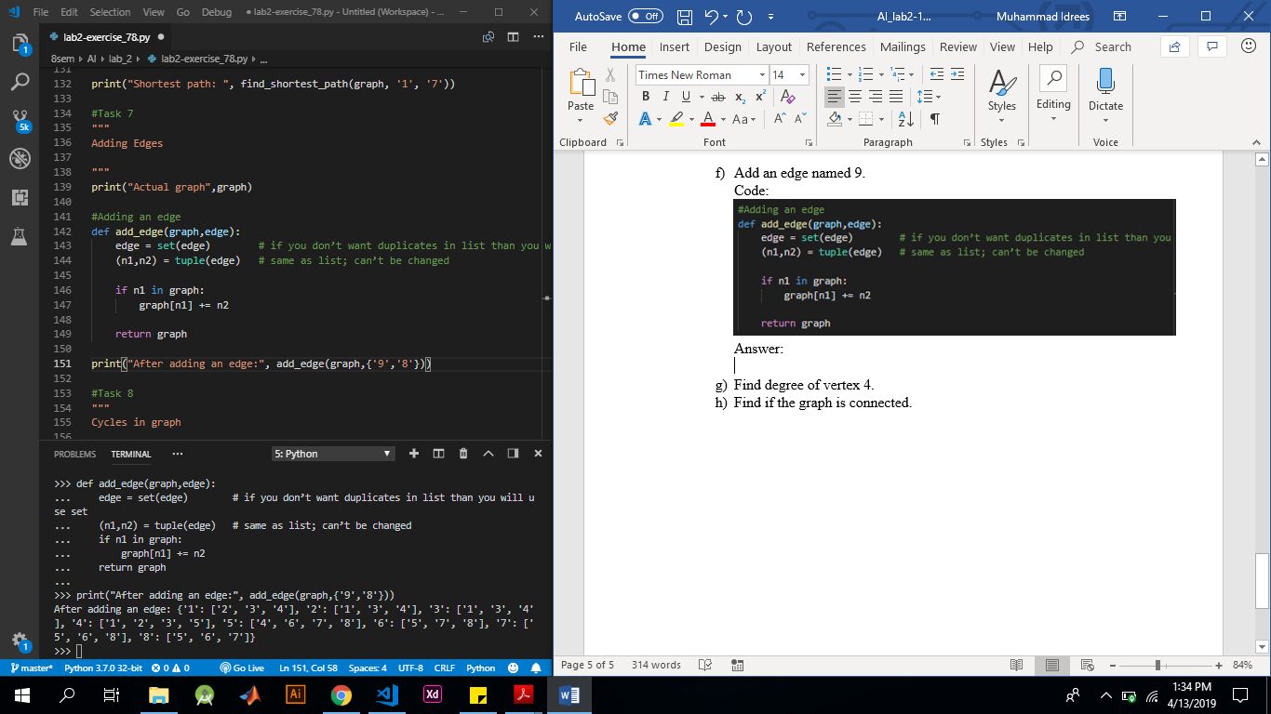

1. Find degree of vertex 4.

Code:

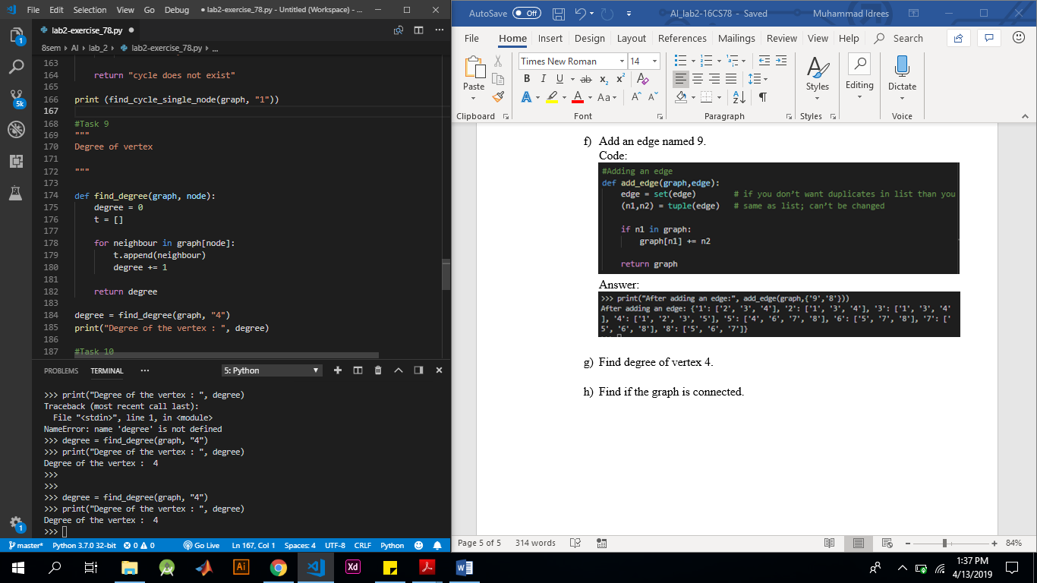

Answer:



1. Find if the graph is connected.

Code:

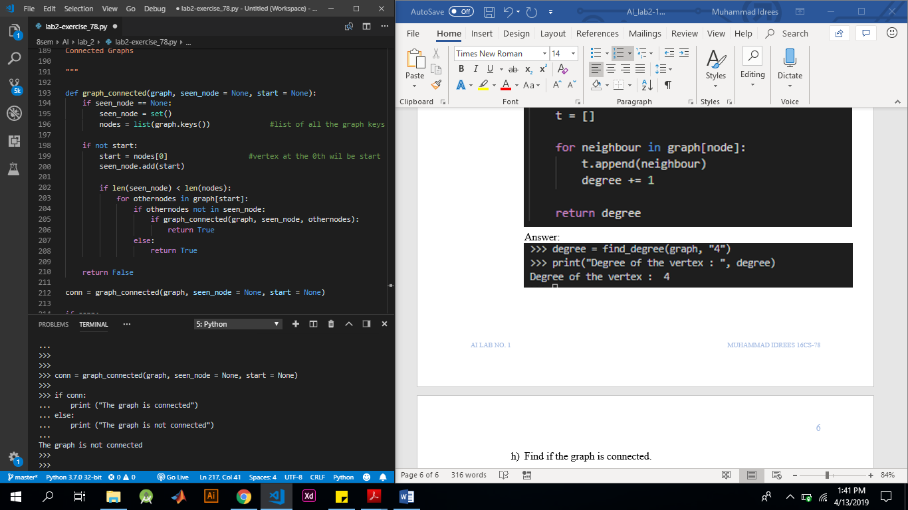

Answer:



1. Consider the following graph:

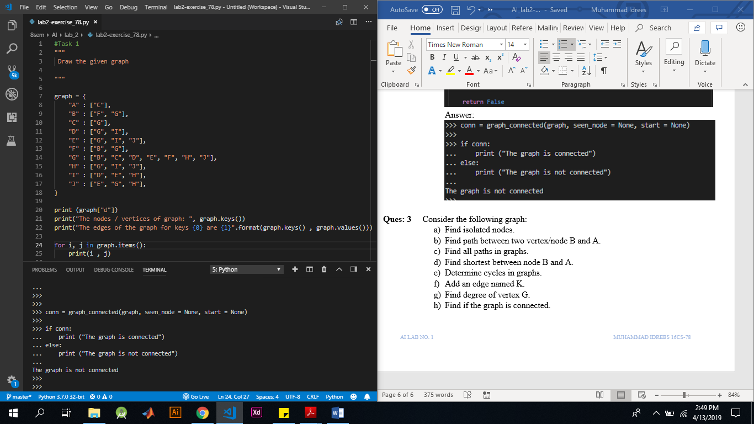

1. Find isolated nodes.

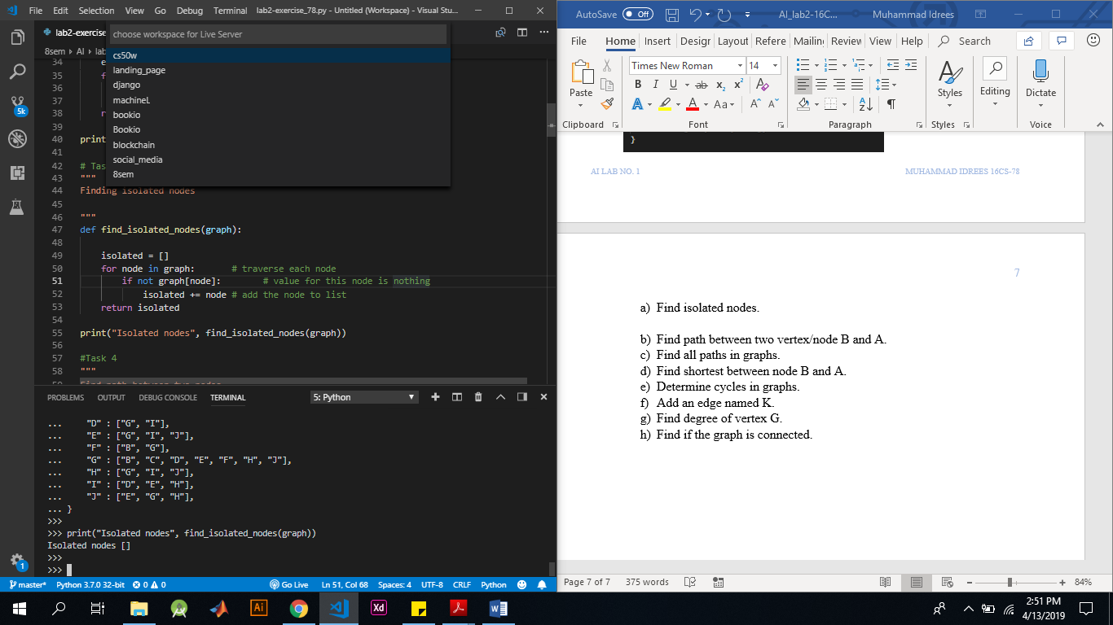

1. Find path between two vertex/node B and A.

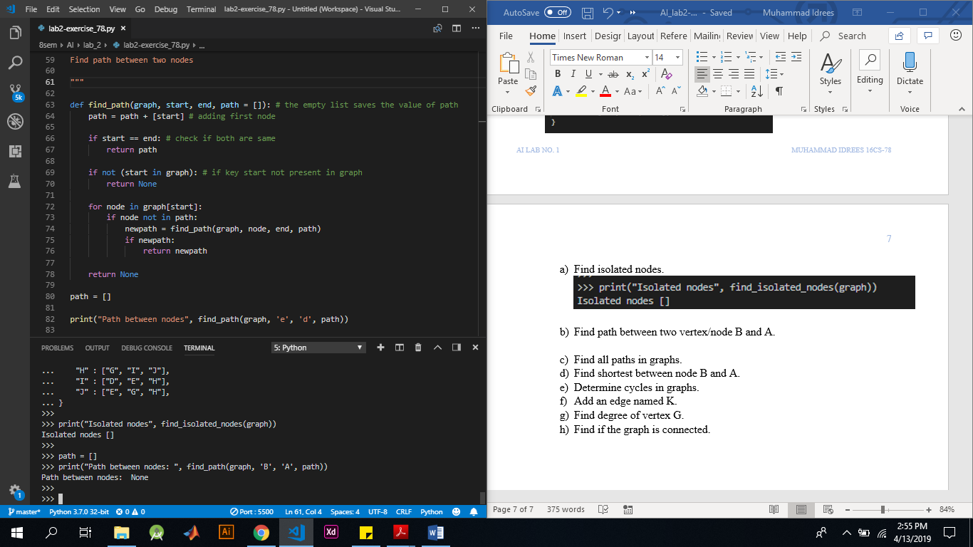

1. Find all paths in graphs.

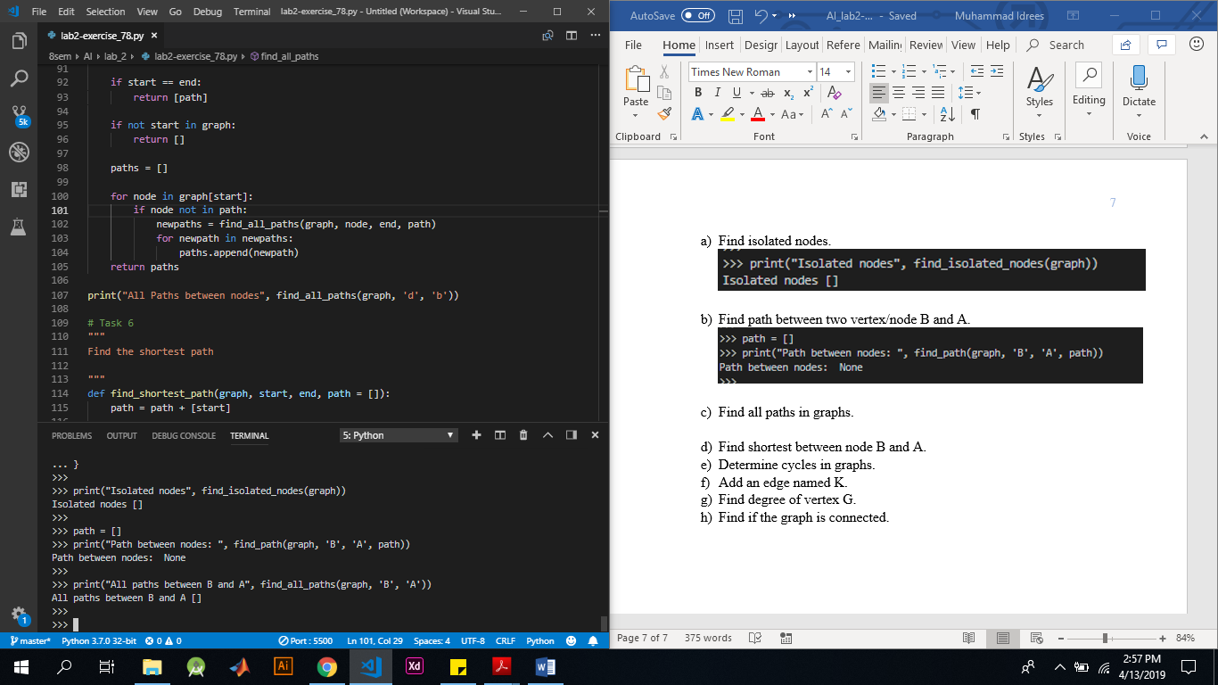

1. Find shortest between node B and A.

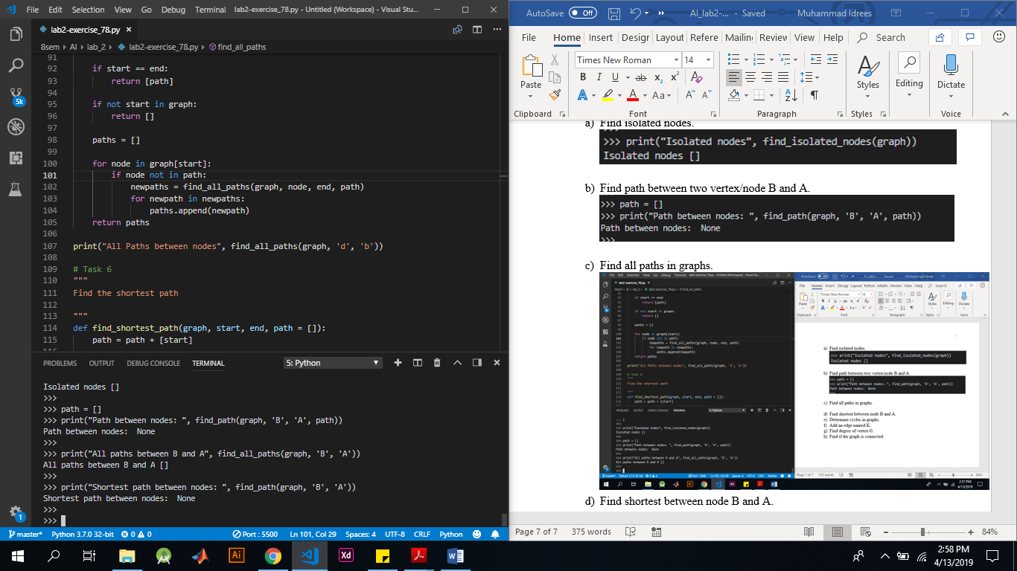

1. Determine cycles in graphs.

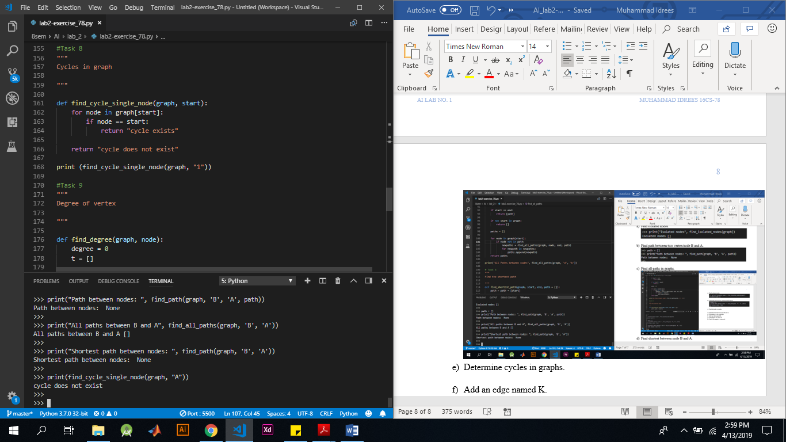

1. Add an edge named K.

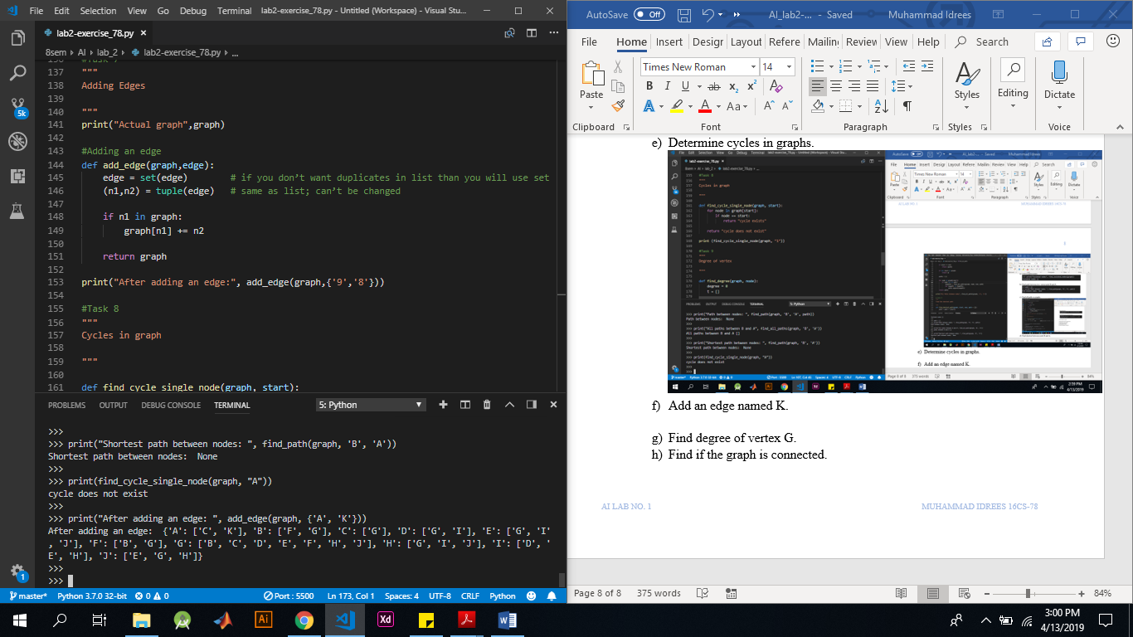

1. Find degree of vertex G.

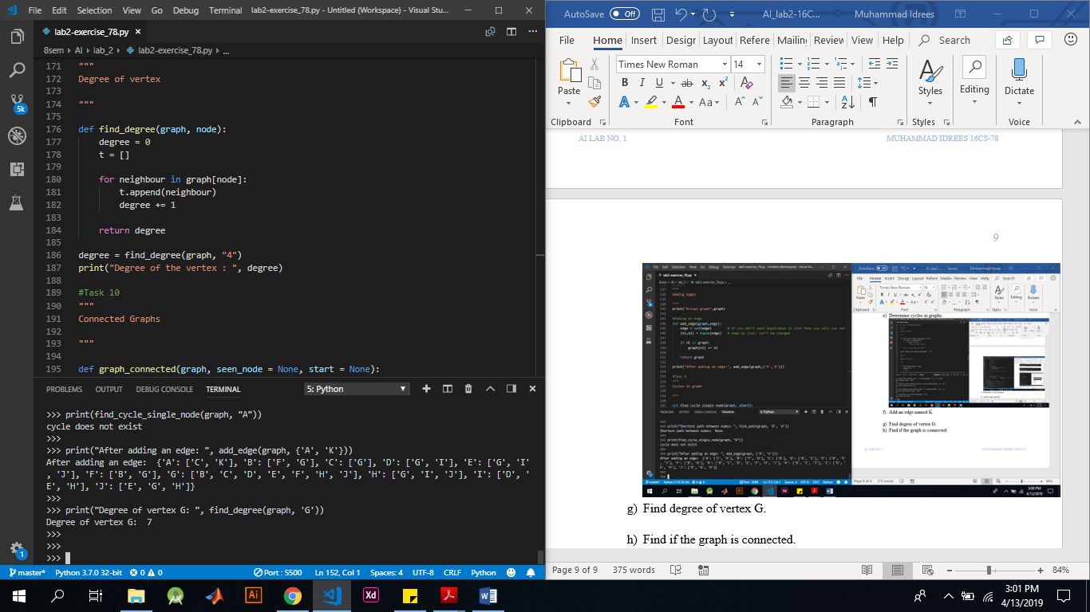

1. Find if the graph is connected.

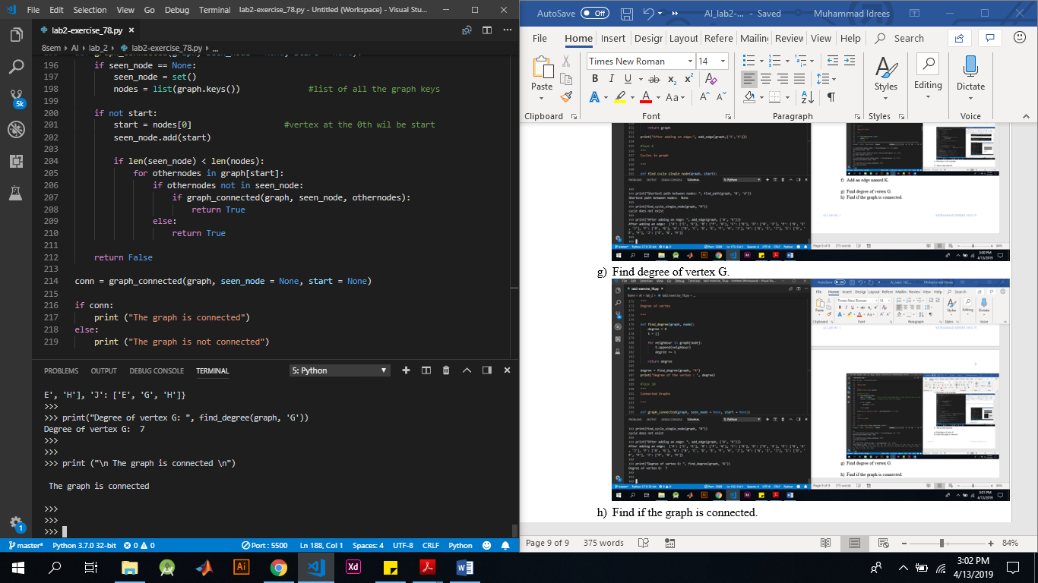

1. Consider the following graph:

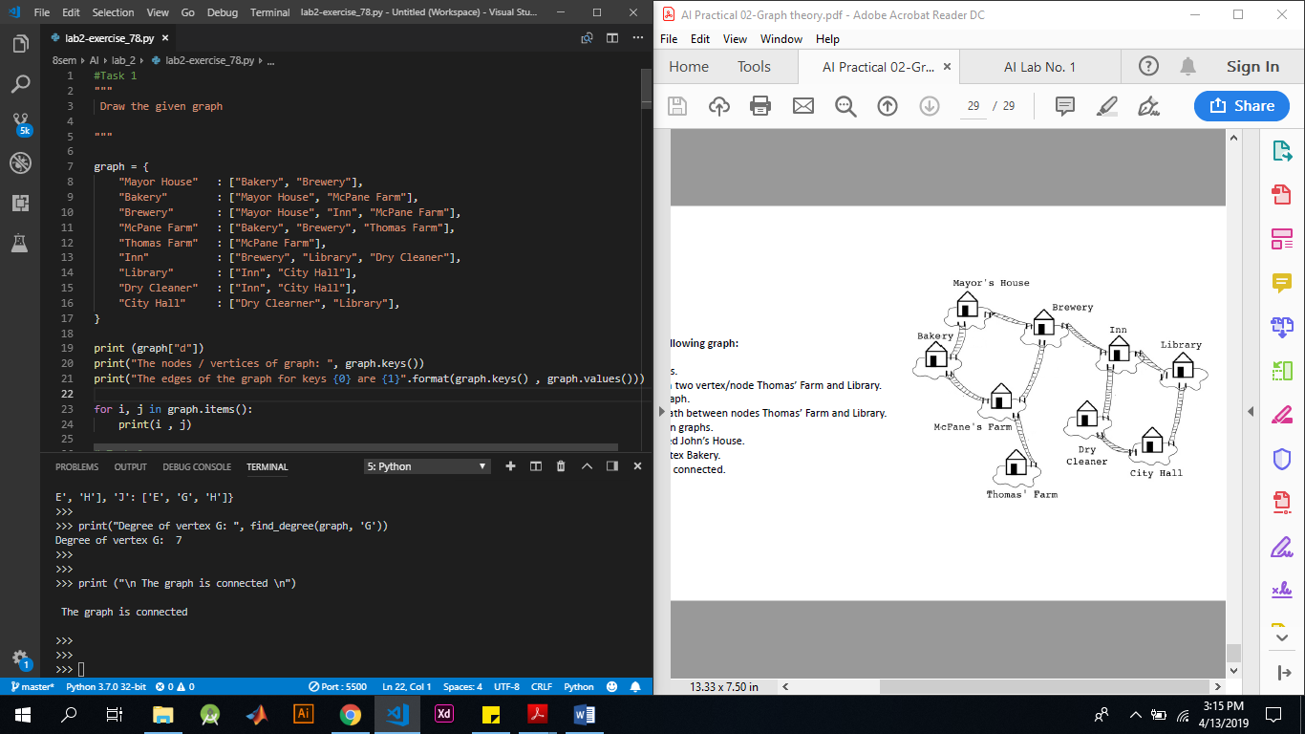

1. Find isolated nodes.



1. Find path between two vertex/node Thomas’ Farm and Library.

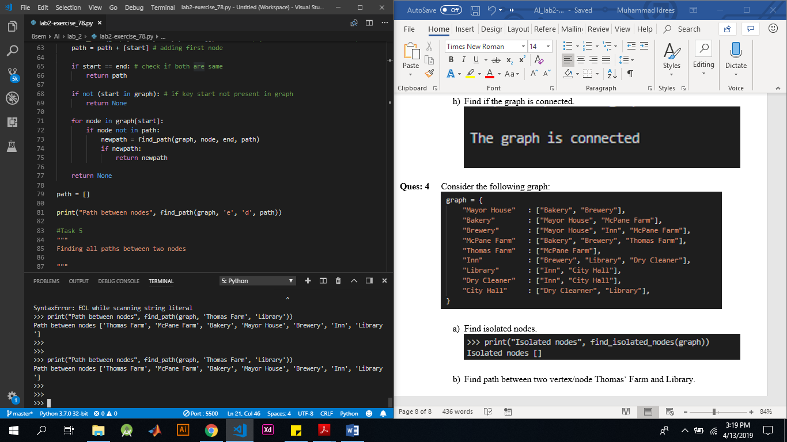

1. Find all paths in graph.

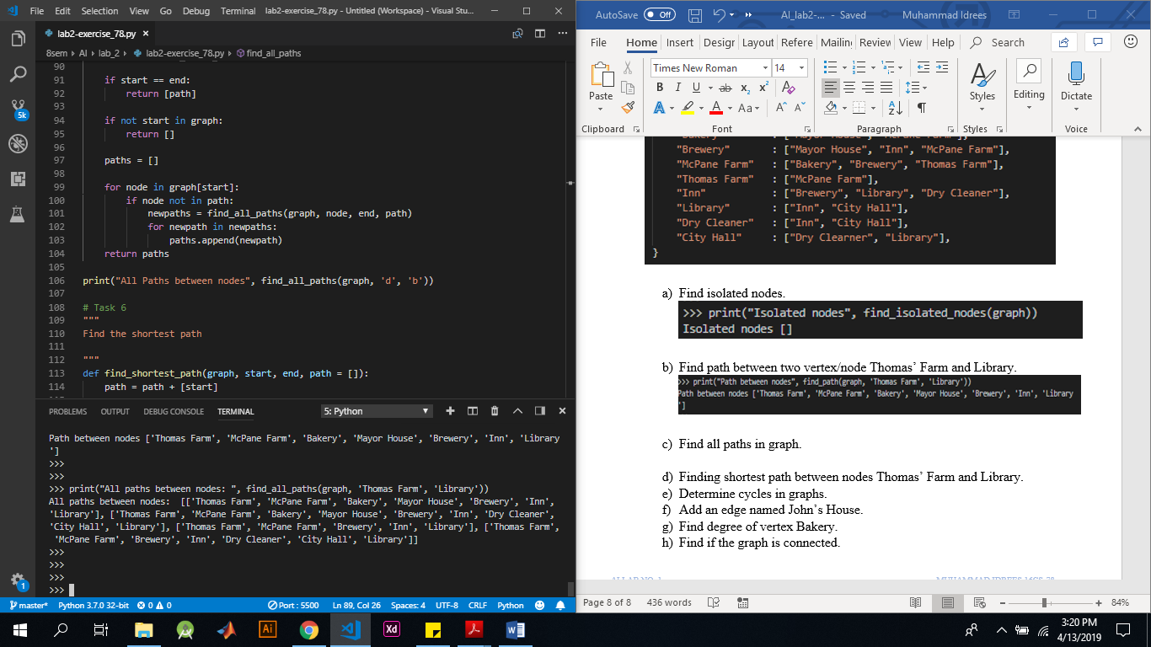

1. Finding shortest path between nodes Thomas’ Farm and Library.

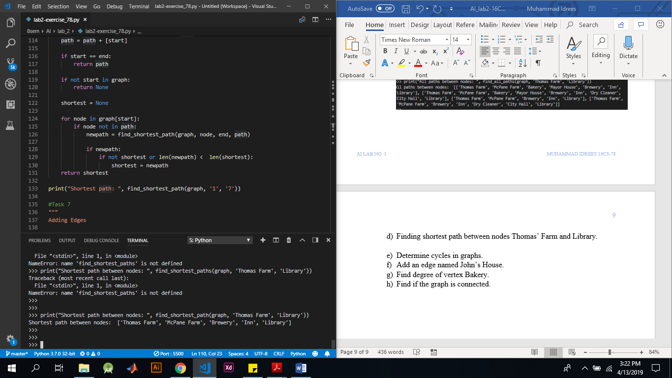

1. Determine cycles in graphs.

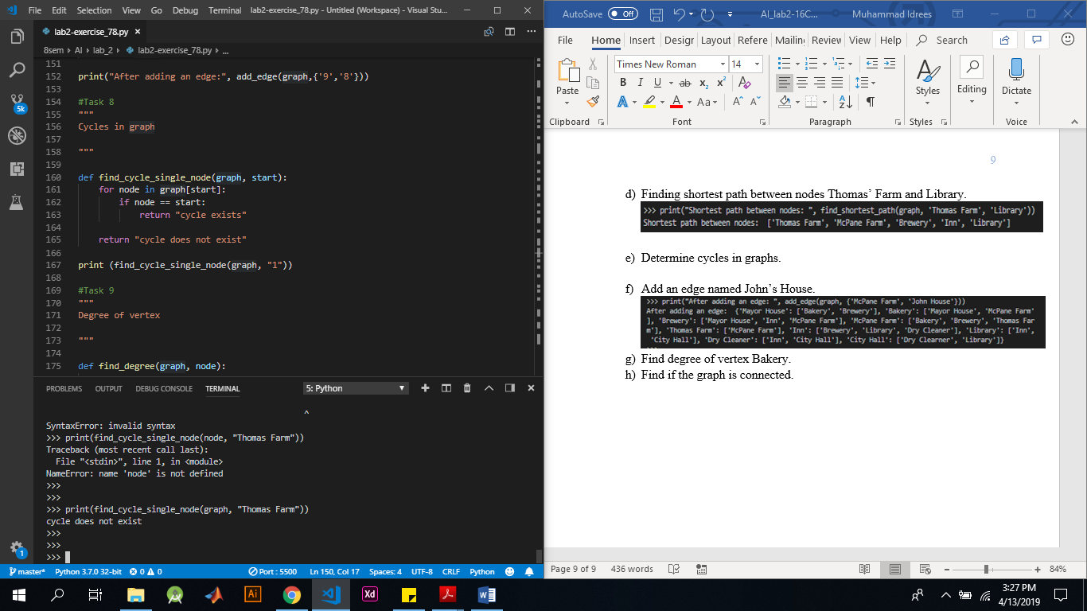

1. Add an edge named John’s House.

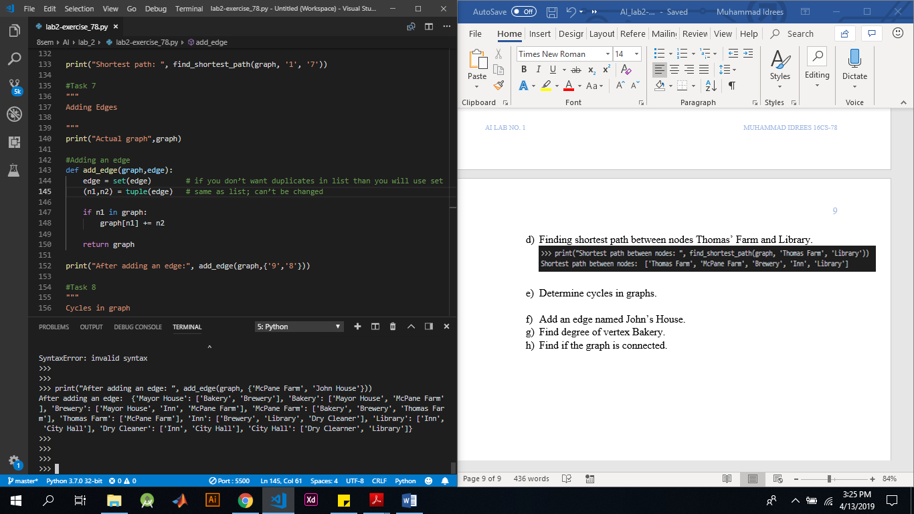

1. Find degree of vertex Bakery.

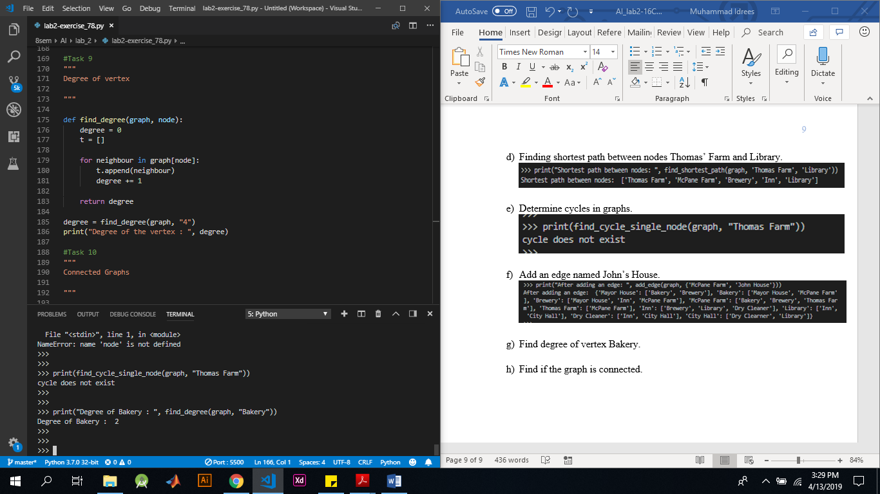

1. Find if the graph is connected.

